What’s New?

**Scania** Training

Earning Scania level II training was a key part in fulfilling Equipment East’s dedication to customers needs. This training allows us to provide customer service, and support on Scania engines mounted in Doosan construction equipment. 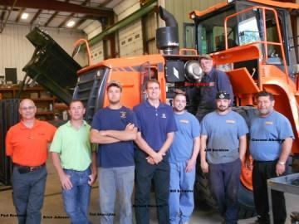

Our Equipment East employees, including the owners, attended the program on our own facility's grounds. Undergoing hands-on sessions to familiarize themselves with the engine family of DC9, 13, and 16 liter engines. These 5, 6, and 8 cylinder engines are used in many Doosan machines.

Delving into all sub-systems of the engine the level II training covers lubrication, cooling, fuel, exhaust, exhaust after treatments, electronic management, as well as the SAIL, SDP3, and MULTI Scania support systems, which include on-line services and product support.

Having factory certified engineers on our Equipment East team is an invaluable asset to the company. Factory training with the Scania product allows Equipment East to keep customers up and running.

"I was impressed by the owners’ attendance and involvement in the class. The desire in all of their eyes during training told me these were people who wanted to learn, accepted the challenge, and appreciated the opportunity to support the Scania product. Having support from the top down, as evidenced by Giovanni Albanese, is an excellent example of the Scania family concept. All of our distributors and dealers become part of the family, and the family is the strongest support system in business today. I look forward to supporting the Equipment East family more and more as the Scania population grows." - Paul Rowlands, Regional Service Manager of Kraft Power Corporation

Proud to add Scania training to Equipment East's line of expertise, we can serve customers even better than before: "We can support any engine Doosan mounts in its excavators and loaders and pride ourselves on our ongoing commitment to customer service and support," said Giovanni Albanese, Equipment East manager. "After all, it's service and support given to our customers after the sale that makes a difference!"

Our highly trained technicians have the benefits of the most up-to-date technical information, our computerized fault-tracing system – Scania Diagnosis, all the right tools for every possible job and ready access to our vast parts inventory. And in the event that parts have to be ordered, they can be delivered within 24 hours at most. This gives our customers peace of mind knowing we can quickly address any issues that could arise.

Equipment East's continuous efforts to improve customer service is a never-ending job. Completing the Scania training is just one more step forward in achieving 100% customer satisfaction.

Doosan’s DL500 Loader

As one of the newest Doosan dealers, Equipment East has since been privileged with some new pieces of machinery that are worth bragging over. Namely, the DL500 loader is one such item.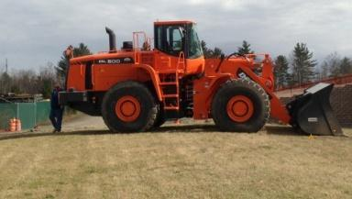

“The DL500 front end loader is a mammoth of a machine. With an operating weight of 66,017lbs, it is Doosan's largest front end loader. We at Equipment East are proud to add this behemoth to our line of heavy equipment.”

With such impressive feats of possibility, the DL500 has an entire [photo album](https://www.facebook.com/media/set/?set=a.184933694989447.1073741826.139132286236255&type=3) dedicated to the piece of equipment. It is not often that such a machine is as photogenic as this loader.

What’s Past?

In the past months, Equipment East featured an array of varying machines and attachments on our social networks – [Facebook](https://www.facebook.com/pages/Equipment-East/139132286236255?ref=tn_tnmn), [Twitter](https://twitter.com/EquipEast), and Google+.

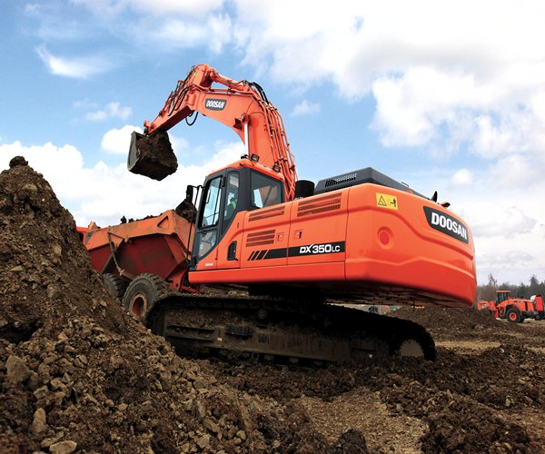

Doosan’s DX350 made in impression on our July post. Combining power, efficiency, reliability, and comfort makes this piece of machinery beyond impressive. Doosan's DX350 is an excavator that is meant to astound you.

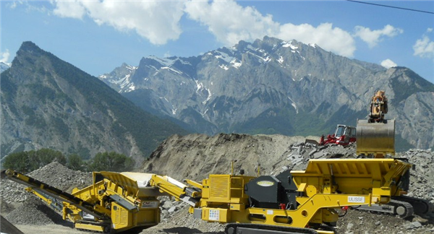

Ulisse jaw crusher by Keestrack also made an appearance on our networks. With its operating-weight of 76,300 pounds and a 5.25 CY feed hopper and crushing as much as 300 tons in an hour, the fully automated Keestrack Ulisse jaw crusher's impressive feats are no myth. See how far this machine can take you and your projects.

What’s Featured?

The Ramfos hydraulic hammer is our featured piece of equipment this month. Though Equipment East is known for our large heavy equipment, our hydraulic hammers by Ramfos make a quality attachment to any excavator. With your pick of hammers for mini, medium, and heavy excavator or skid steer loaders, our Ramfos hydraulic selections are equipped to meet the demands of most any job.

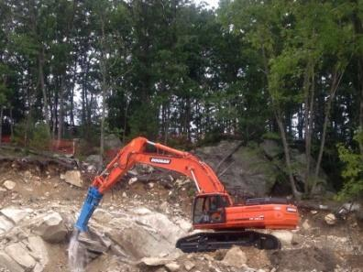

**LiuGong Machine in the News**

In lieu of necessary demolition in Burlington, MA, one of our LiuGong excavators was called upon to complete the job. Local crew by Erland Construction succeeded in finalizing the project. The Nordblom Third Avenue project will revive Kerr Mill, upgrading the UMass Dartmouth facility.

**Come in to our facility today and try out our reliable equipment from mini excavators and loaders to 100,000 lb machines.**

**For more information about our equipment or suggestions for the newsletter, contact us.**

**Address: Equipment East, LLC.**

**61 Silva Lane  Dracut, MA 01826**

**Telephone: (978) 454-3320**

**Fax: (978) 454-3325**

**eMail: questions@equipmenteast.com**